**Problem 2 and 3:**

**Problem 4:**

Min Date

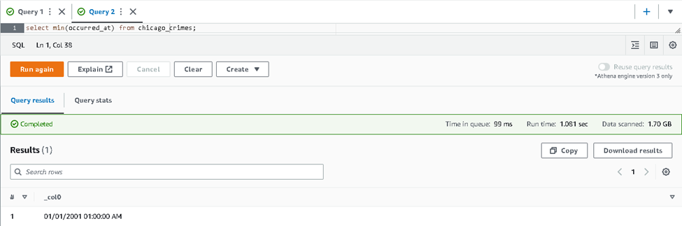

Max Date

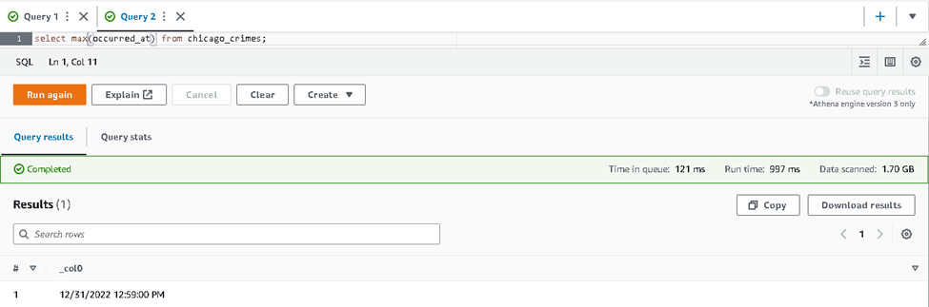

Add the primary_type

**Problem 7**

Most dangerous

Least dangerous

I made a mistake when imported the data into table.

**Problem 8**

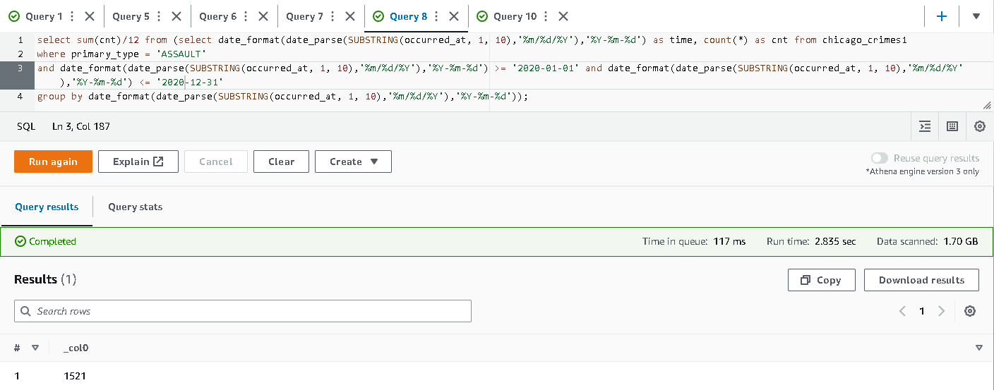

The average crime of assault in 2021 increases compared to 2020. I used the wrong denominator in my previous answer.